**The Cumulative Distribution Function (CDF) of the DNS resolution time for Experiment 1, Experiment 2, and Experiment 3.**

**Experiment 1: Run your DNS resolver**

**Experiment 2: Now use your local DNS resolver**

**Experiment 3: Change the DNS resolver to Google’s public DNS**

Below is the CDF graph based on the measurement of 25 domains from [alexa.com/topsites](http://alexa.com/topsites) website.

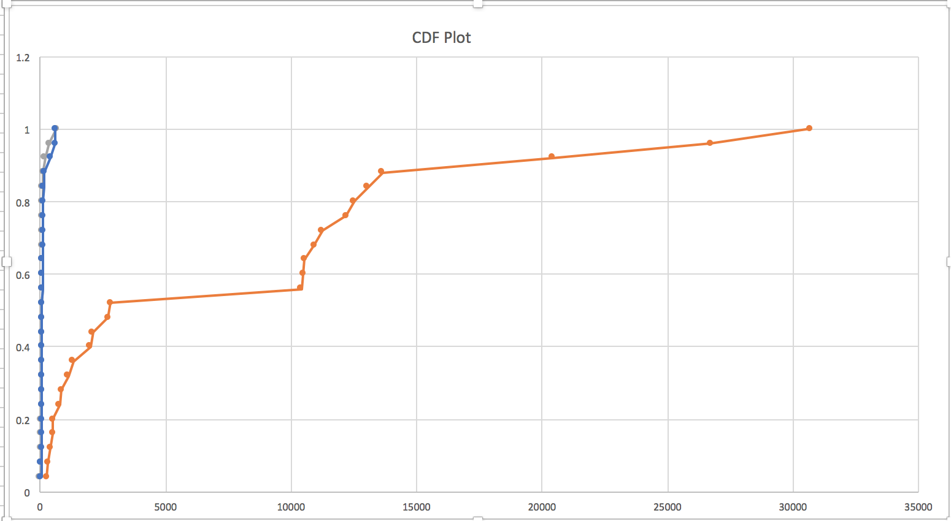

milliseconds

* - My Resolver
* - Google Resolver
* - Local Resolver

As we may see, MyResolver is taking too much time to resolve compared to the local-resolver and google’s public resolver. The reason for this is can be that each time a dns resolution query has been made using MyResolver, it contacts the root servers on <https://www.iana.org/domains/root/> and then goes down recursively till the it finds any resolution for the domain. But for local DNS, it just make a query to local dns, which mostly has cached most of the top websites IPs at its disposal returning the required IP in less time. Same is the case with Google’s Public IP where most of the domains IP address may be cached at its own server-base. Even if local/google resolver can’t resolve IP at their own zone, the recursion call won’t be till the main NS to fetch the actual IP as compared to MyResolver.

The individual CDF’s for all the three